

Assignment 3A: Project Standup 3

COS30045 – Data Visualisation
Teaching Period 02, 2026

Team Members – 1E
Syed Muhammad Mahdi | 105172195
Dilhani Seneviratne | 101133033

Submission Folder GitHub Link
Word Count: 708

Table of Contents
1.0 COMPLETED TASKS 3
2.0 ESTIMATE OF CONTRIBUTION 3
3.0 TEAM TASK TO-DO LIST 4
4.0 TEAMWORK ISSUES 4
5.0 DRAFTS 5

1.0 Completed Tasks
The team's attention has been directed towards refinements of visualisations, enhancing the interactivity of the website and the technical work of Assignment 3C: Website and Visualisation since the last standup.

Syed finished the 3 D3 visualisations with the processed OECD healthcare expenditure and life expectancy data. The visualisations also include a scatter plot comparing healthcare spending and life expectancy, as well as line charts depicting the trend in healthcare spending and life expectancy between 2015 and 2024.

Tooltips added for reference of country information, made interactive. The country highlighting was also added to the line charts so that the trends of individual countries can be seen more easily.

Dilhani worked on the front end of the website and their documentation. Her work helped to enhance the visual narrative by making the interface easy to navigate and read. The five guiding questions were added to the website content, so that they could link the visualisations to the project's research purpose.

The website was tested on screen resolution sizes for desktop and mobile. The mobile layout was enhanced with the ability to horizontally scroll through charts. The last website testing was done and site was deployed to the Mercury server.
The new project files were committed and pushed to the common GitHub repository.

2.0 Estimate of Contribution
The team still split up work on a case by case basis and as per individual strengths. Syed oversaw the data handling process, created and enhanced the visualisations in D3, added interactivity, and tested the site on desktop and mobile. Dilhani was involved in front end presentation, website readability, technical documentation and the Project Process Book.
Both members of the team helped build the website and made efforts to meet the other assessment criteria. The contribution table below shows how each member contributed and advanced in this reporting period.
 | Syed |  | Dilhani
Refining D3 visualisations and interactivity | 5.0 hrs | 80% | 1.0 hrs | 20%
Website content and front-end presentation | 2.0 hr | 65% | 3.0 hr | 65%
Website testing and deployment | 3.0 hrs | 75% | 1.0 hrs | 25%
Writing Standup 3 report | 0.0 hrs | 0% | 2.0 hrs | 100%
Writing up Assignment 3B: Project process book | 1.5 hrs | 50% | 1.5 hrs | 50%
Note on Task Percentages: Percentages reflect the cumulative progress of the total task toward 100% completion for the overall
project. Where both team members list an identical percentage (e.g. 65%), it indicates a collaborative task where both members contributed equally.

The team continued to work collaboratively, with tasks divided according to individual strengths. Syed spent 5 hours refining the D3 visualisations and interactivity, 2 hours on website content and front-end presentation, and 3 hours on website testing and deployment. Dilhani contributed 1 hour to visualisation refinement, 3 hours to website content and front-end presentation, and 1 hour to testing and deployment. Dilhani also spent 2 hours preparing the Standup 3 report. Both team members contributed 1.5 hours each to the Project Process Book. Syed logged a total of 11.5 hours, while Dilhani logged 8.5 hours during this reporting period.

3.0 Team Task To-Do List
List of things to get done before this next standup:

1.Finish and turn in Assignment 3A: Project Standup 3.
2.Complete Assignment 3B: Project Process Book (Data preparation process, Design decisions for visualisation, Development evidence and the final screenshots.)
Do user testing of the website and visualisations, record the feedback and any improvements.
Check the Mercury website and GitHub repository, to make sure that project files have been finalized.
Make Assignment 3A: Project Standup 4.
Finish Assignment 3D: Project Reflection & Peer Review, and make final submissions.

Technical implementation of the website is done. Next reporting will be user evaluation, documentation and requirements for final assessment.

4.0 Teamwork Issues
No teamwork issues were reported during this reporting period. The team continued to use Microsoft Teams for communication and GitHub for sharing project files and tracking changes. Clear task allocation allowed the members to progress with their respective responsibilities.

5.0 Drafts
Current version of Assignment 3C: Website and Visualisation
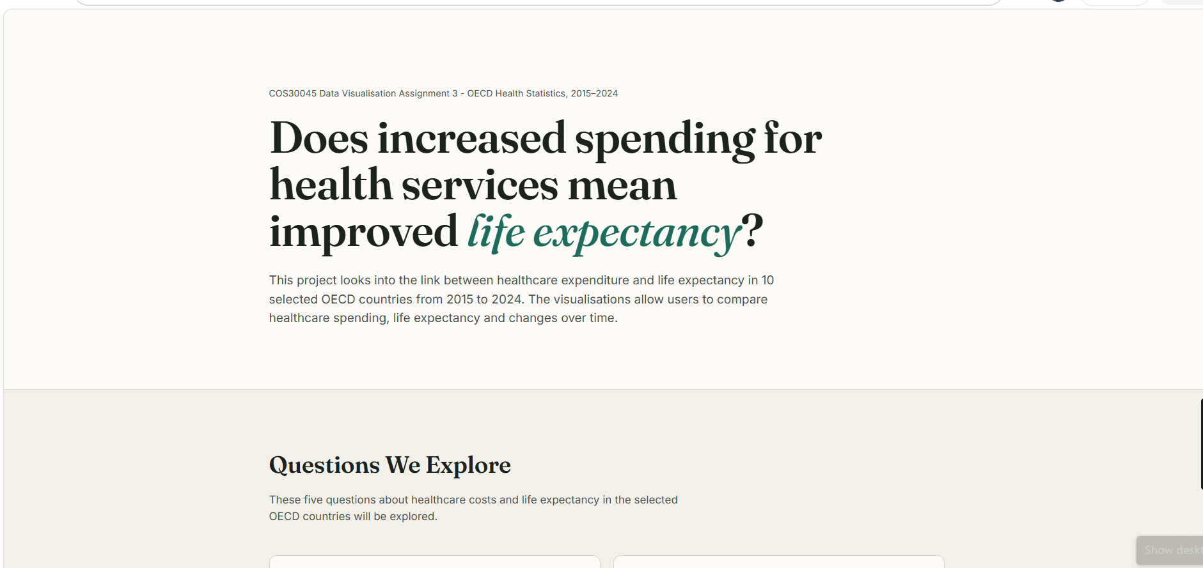
Figure 1: Website homepage and guiding questions

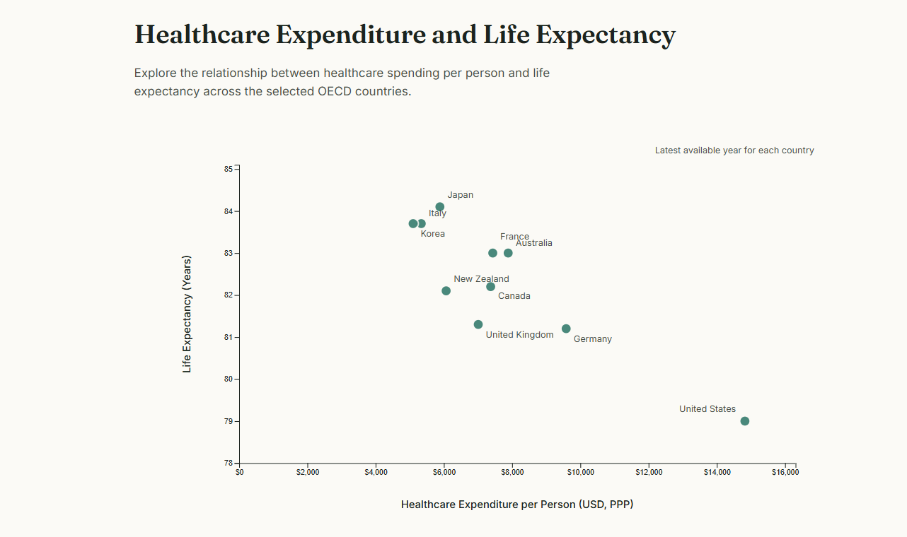
Figure 2: Healthcare spending and life expectancy scatter plot

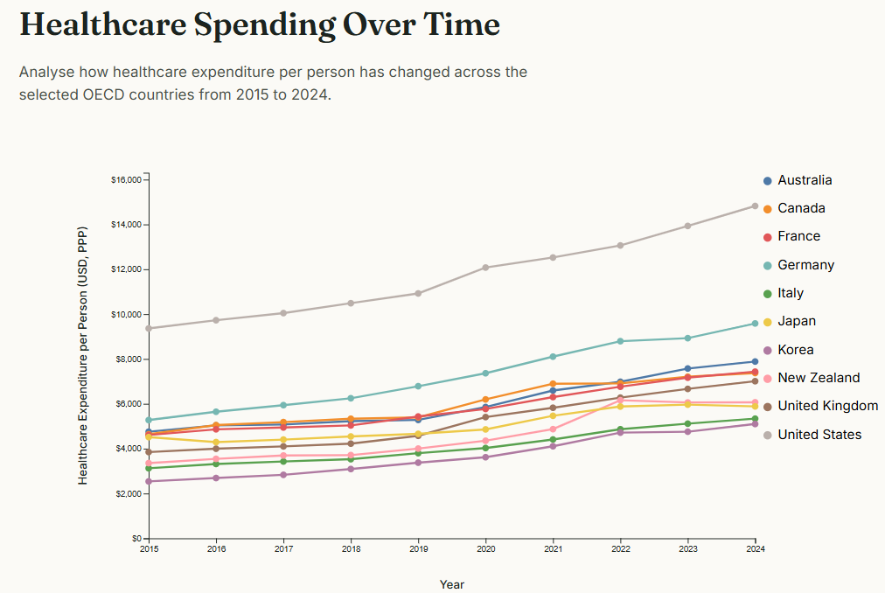
Figure 3: Interactive healthcare spending line chart
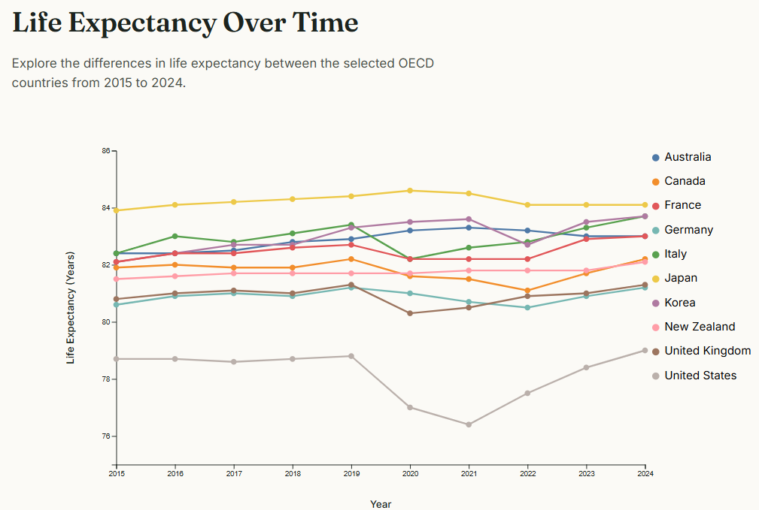
Figure 4: Interactive life expectancy line chart

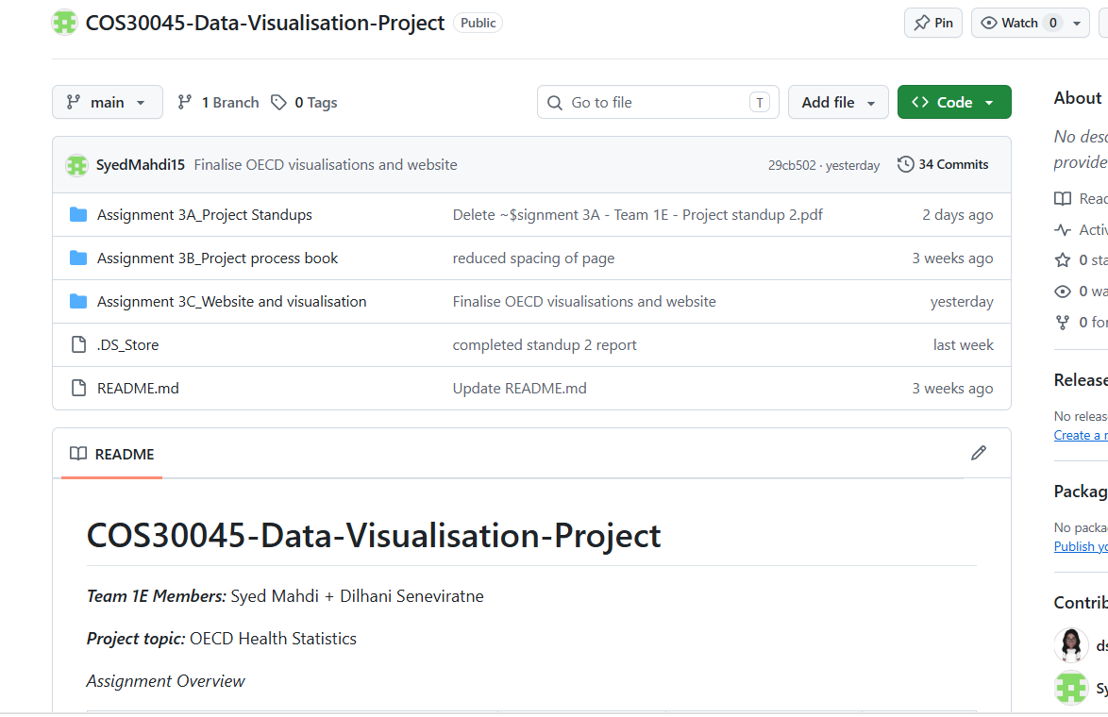
Figure 5: Updated project repository
Current version of Assignment 3B: Project Process Book

